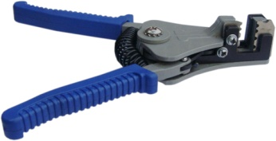

**Type 6YTTL**

**Unsheathing and stripping tools**

Wire strippers for 2 conductors flat heating cable.

Unsheathing and stripping these lat special shape leads is a long and tough work, causing a lot of waste.

We have developed these tools specifically for stripping and unsheathing to reduce these times, and significantly reduce installation times. Each plier comes with a set of jaws.